Health Claims Fee Detail Report
In May 2016 Cigna rolled out a series of program level fees to be assessed to the customer, these new program fees are captured on the Health Paid Claims Reports under a summarized claim type of ‘FEE’. The Health Claims Fee Detail Report is a new report specifically designed to support and provide customer (subscriber) level details of the rolled up Fee on the HPC report. The new HCFD report will be available October 2016 and upon release will only be available to clients with ASO funding. The HCFD report for Fully Insured groups release has yet to be determined.
The fee details on the HCFD report, currently incorporates programs such as MuscleSkeletal, Medical Management Evolution, and State Assessment Recovery; however this report will also contain any future program fee details.
*Note the report will be available to users Monday, October 17, 2016, if you have access to the Health Paid Claims report, then you will automatically be granted access to the Fee Detail report.
Accessing Health Claim Fee Detail
The Health Claim Fee Detail report is located under the Claims Reports section under the CRP reports.
*This link is currently unavailable for Fully Insured Groups
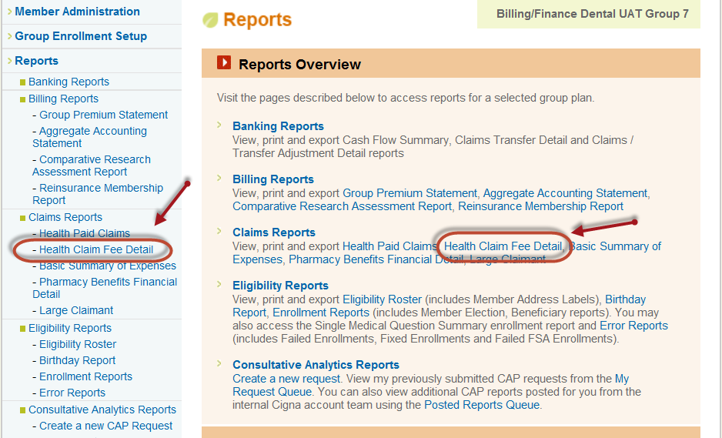

The Health Claim Fee Detail report was written in the new Cognos reporting tool. When you click on the report link the Cognos parameter page presents. The report is a detailed report, therefore a summary option will not be available. If your reporting needs require a summary the Health Paid Claims report will need to be used to capture summarized information.
Parameters:
*Note: If there is no reporting data available for your group “No statements are available at this time” will display.
- Dates:
  - Paid Date Range
    - Custom Dates
    - By Month (defaults)
- Classification: Defaults of ALL
  - Subgroup(s)
  - Class(es)
  - Plan(s)
- Fee Details
  - Fee Type(s) (defaults to “All”)
  - The Fee Types
    - Current available
      - Med Mgment CPLT
      - State Assessment
      - Musculoskeletal Management
- Below the Fee Type(s) is an option to enter a “Fee ID” which is not a required field.
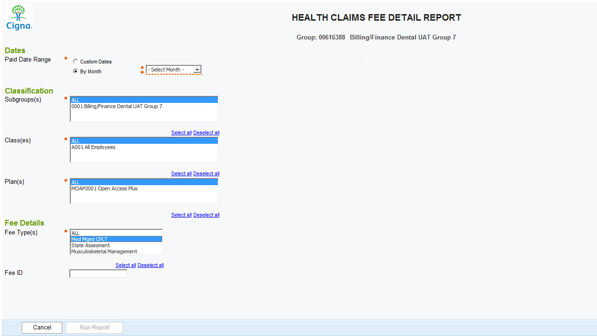
Report Output
Once the user selects all of the required options on the parameters page and selects “Run Report”, a new window will open displaying the Health Claims Fee Detail Report.
The Health Claims Fee Detail contains a report header section, which includes:
*Paid Date Range *Fee Types *Subgroups *Fee ID (default value to “Not Entered”) *Classes *Column Sorting *Plans
The Report Body includes columns for:
*Subgroup ID * Patient Rel. Code *Class ID * Fee Description *Plan Description * Paid Date
*Member ID * Desc Fee Amount *Member Name * Fee ID *Patient First Name * Fee Type
The report output page has three icons on the top right. The blue back arrow returns the user to the Cognos parameter page. The other two icons allow the user to export the report output in Excel or PDF formats.

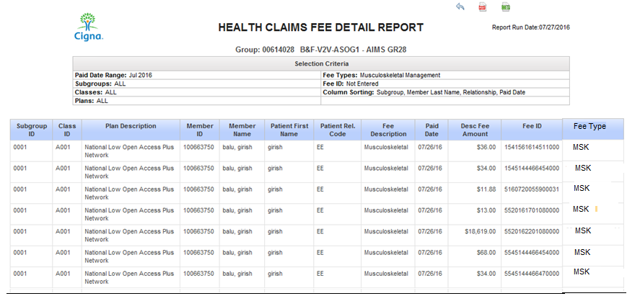

Fee Descriptions

The Fee Descriptions that will display on the report for the Fee Type(s) selected will be the following:
Note: This will be an ever-changing list as other fees are added.

Project Fee Type(s) Fee Description
FFV MSK P551 Musculoskeletal Management Musculoskeletal
Medical Management Evolution Med Mgmt CPLT Care Mgmt CPLT
State Assessment Recovery State Assessment AK Immunization
State Assessment Recovery State Assessment CA Fraud H & D
State Assessment Recovery State Assessment CA Health Care
State Assessment Recovery State Assessment CA MCO Assmt
State Assessment Recovery State Assessment CO Market Exchg
State Assessment Recovery State Assessment CT Immunization
State Assessment Recovery State Assessment CT Public Hlth
State Assessment Recovery State Assessment ID Immunization
State Assessment Recovery State Assessment ME Immunization
State Assessment Recovery State Assessment MA – CHIA
State Assessment Recovery State Assessment MS Comp Hlth In
State Assessment Recovery State Assessment MT Genetics
State Assessment Recovery State Assessment NH Immunization
State Assessment Recovery State Assessment NM Immunization
State Assessment Recovery State Assessment OR Reinsurance
State Assessment Recovery State Assessment RI Vaccine Purc
State Assessment Recovery State Assessment SD High Risk
State Assessment Recovery State Assessment VT Vaccine Purc
